EC-467 Mobile Application Development

BS (CE)-2021 LAB REPORT #13
Submitted By:

Reg. No. | Name
21-CE-009 | Huzaifa Shahbaz

Department of Computer Engineering
HITEC University Taxila
 | Presentation  (Format(0.5)+  Title (0.5)+  Conclusion(1)  +Procedure(2)  +Objective(1)) | Calculation/ Coding | Observation/  Program Results | Total
Total | 5 | 5 | 5 | 15
Obtained

Lab Instructor.
Dr. Muhammad Bilal

LAB REPORT #13
Android Broadcast Receiver
Introduction: Broadcast Receivers simply respond to broadcast messages from other applications or from the system itself. These messages are sometime called events or intents.
Objectives of the experiment: i. To get basic understanding regarding android broadcast receiver. ii. To get basic understanding regarding how to use android broadcast receiver. iii. To get to know about the benefits related to android broadcast receiver.
Tools: Android Studio Jellyfish
Class Task JAVA CODE OF Main Activity: package com.huzaifashahbaz.androidbroadcastreceiverapp;
import android.content.Intent;
import android.content.IntentFilter;
import android.os.Bundle;
import android.view.View;
import androidx.appcompat.app.AppCompatActivity;
public class MainActivity extends AppCompatActivity {
@Override
protected void onCreate(Bundle savedInstanceState) {
super.onCreate(savedInstanceState);
setContentView(R.layout.activity_main);
MyReceiver receiver=new MyReceiver();
IntentFilter filter1=new IntentFilter("android.intent.action.AIRPLANE_MODE");
registerReceiver(receiver,filter1);
IntentFilter filter2=new IntentFilter("com.example.mybroadcastreceiver.CUSTOM_INTENT");
registerReceiver(receiver,filter2);
}
public void sendBR(View view)
{
Intent intent=new Intent("com.example.mybroadcastreceiver.CUSTOM_INTENT");
sendBroadcast(intent);
}
}
JAVA CODE OF My Receiver: package com.huzaifashahbaz.androidbroadcastreceiverapp;
import android.content.BroadcastReceiver;
import android.content.Context;
import android.content.Intent;
import android.widget.Toast;
public class MyReceiver extends BroadcastReceiver {
@Override
public void onReceive(Context context, Intent intent)
{
Toast.makeText(context, "Intent Detected:"+ intent.getAction(),Toast.LENGTH_LONG).show();
}
}
XML CODE OF Main Activity: <?xml version="1.0" encoding="utf-8"?>
<LinearLayout xmlns:android="http://schemas.android.com/apk/res/android"
xmlns:tools="http://schemas.android.com/tools"
xmlns:app="http://schemas.android.com/apk/res-auto"
android:layout_width="match_parent"
android:layout_height="match_parent"
android:orientation="vertical"
android:gravity="center">
<Button
android:layout_width="match_parent"
android:layout_height="wrap_content"
android:onClick="sendBR"
android:text="Send BR"/>
</LinearLayout>
Results: 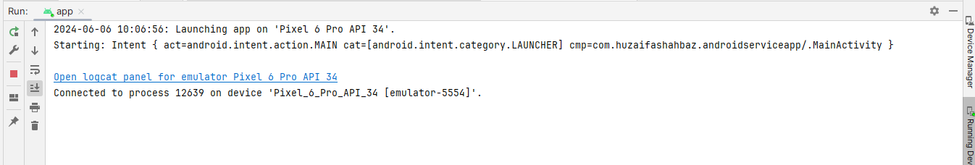
OUTPUT: 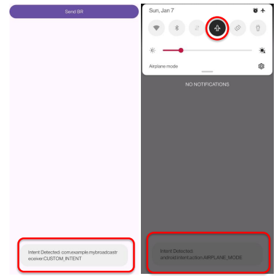
HOME TASK: Consider previous browser app that you have designed in Lab task # 12, now use two broadcast events i.e. connectivity change, and WiFi connectivity, update the app to detect those events and display message to the user if connectivity and or WiFi status is changed using toast message, extra marks will be given for whom those use background or status icon to show if connectivity and/or WiFi is enable or not.
JAVA CODE OF Main Activity: package com.huzaifashahbaz.wifibroadcastreceiver;
import android.content.Intent;
import android.content.IntentFilter;
import android.net.ConnectivityManager;
import android.net.wifi.WifiManager;
import android.os.Bundle;
import android.view.View;
import androidx.appcompat.app.AppCompatActivity;
public class MainActivity extends AppCompatActivity {
private MyReceiver receiver;
@Override
protected void onCreate(Bundle savedInstanceState) {
super.onCreate(savedInstanceState);
setContentView(R.layout.activity_main);
receiver = new MyReceiver();
IntentFilter filter1 = new IntentFilter(ConnectivityManager.CONNECTIVITY_ACTION);
registerReceiver(receiver, filter1);
IntentFilter filter2 = new IntentFilter(WifiManager.WIFI_STATE_CHANGED_ACTION);
registerReceiver(receiver, filter2);
}
@Override
protected void onDestroy() {
super.onDestroy();
unregisterReceiver(receiver);
}
public void sendBR(View view) {
Intent intent = new Intent("com.example.mybroadcastreceiver.CUSTOM_INTENT");
sendBroadcast(intent);
}
}
JAVA CODE OF My Receiver: package com.huzaifashahbaz.wifibroadcastreceiver;
import android.content.BroadcastReceiver;
import android.content.Context;
import android.content.Intent;
import android.net.ConnectivityManager;
import android.net.NetworkInfo;
import android.net.wifi.WifiManager;
import android.widget.Toast;
public class MyReceiver extends BroadcastReceiver {
@Override
public void onReceive(Context context, Intent intent) {
String action = intent.getAction();
if (ConnectivityManager.CONNECTIVITY_ACTION.equals(action)) {
ConnectivityManager cm = (ConnectivityManager) context.getSystemService(Context.CONNECTIVITY_SERVICE);
NetworkInfo activeNetwork = cm.getActiveNetworkInfo();
boolean isConnected = activeNetwork != null && activeNetwork.isConnectedOrConnecting();
if (isConnected) {
Toast.makeText(context, "Connected to Internet", Toast.LENGTH_LONG).show();
} else {
Toast.makeText(context, "Disconnected from Internet", Toast.LENGTH_LONG).show();
}
} else if (WifiManager.WIFI_STATE_CHANGED_ACTION.equals(action)) {
int wifiState = intent.getIntExtra(WifiManager.EXTRA_WIFI_STATE, WifiManager.WIFI_STATE_UNKNOWN);
switch (wifiState) {
case WifiManager.WIFI_STATE_ENABLED:
Toast.makeText(context, "WiFi Enabled", Toast.LENGTH_LONG).show();
break;
case WifiManager.WIFI_STATE_DISABLED:
Toast.makeText(context, "WiFi Disabled", Toast.LENGTH_LONG).show();
break;
default:
break;
}
} else {
Toast.makeText(context, "Intent Detected: " + action, Toast.LENGTH_LONG).show();
}
}
}
XML CODE OF Main Activity:
<?xml version="1.0" encoding="utf-8"?>
<LinearLayout xmlns:android="http://schemas.android.com/apk/res/android"
xmlns:app="http://schemas.android.com/apk/res-auto"
xmlns:tools="http://schemas.android.com/tools"
android:layout_width="match_parent"
android:layout_height="match_parent"
android:orientation="vertical"
android:gravity="center"
tools:context=".MainActivity">
<Button
android:layout_width="match_parent"
android:layout_height="wrap_content"
android:onClick="sendBR"
android:text="Send Broadcast"/>
</LinearLayout>
Results: 
OUTPUT: 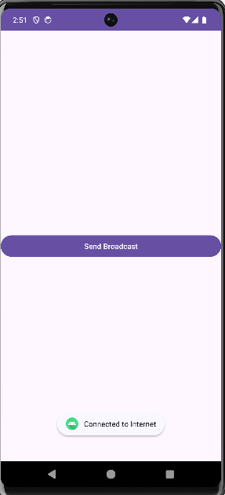 Conclusion: In this lab I had learn how to make broadcast receiver apps by using java and xml linear layout code and I also made the airplane mode broadcast receiver and Wi-Fi mode broadcast receiver.

